## Extend “MyDevice” app

1. Add the “vibration” plugin.
2. Make a vibration when the camera makes a picture.
3. Assert it with alert('Just vibrated for a sec');
4. Update the camera page footer like this:



1. Create a new page called “geolocation-page”
2. Via geolocation plugin make it look like this:

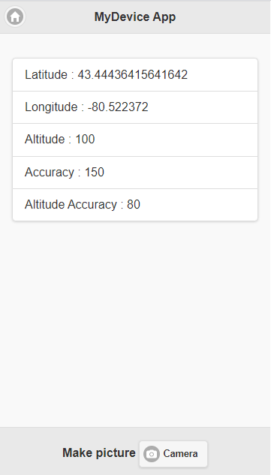

1. Create an account here: <https://console.kinvey.com/sign-up> .
2. Then login here: <https://console.kinvey.com/apps>.
3. Click on Create an App:

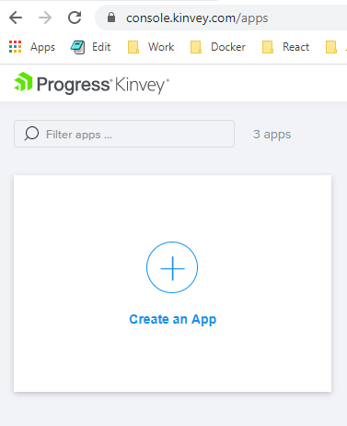

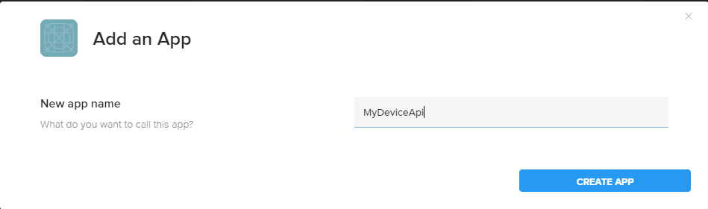

1. Click on Identity -> Users

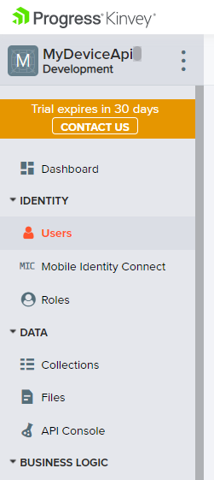

1. Then ADD USER

